Chapter 9, Solution 53.

Find I₀ in the circuit in Fig. 9.60.

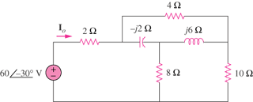

Figure 9.60
For Prob. 9.53.

Solution

Convert the delta to wye subnetwork as shown below.

Z₁ Z₂

I_{o} 2
Z₃

+
10
V 8

-

Z

